Name: William A. Brannon

Assignment: Lab Assignment Report #4

Date Due: Monday, February, 18, 2019

Class: Fundamentals of Programming III Section #1

**Program Output**

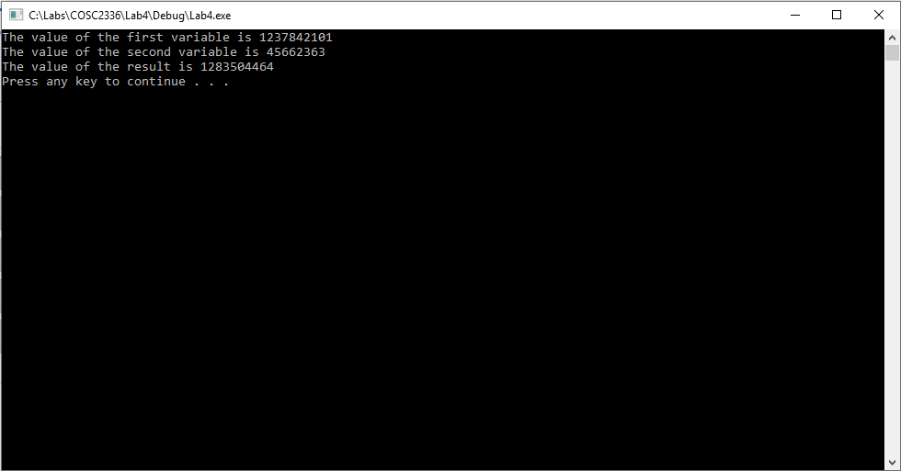

**Lab4.cpp**

// Lab4.cpp : adding large numbers

// By William A. Brannon on 02/14/2019

#include "stdafx.h"

#include <iostream>

#include <vector>

#include <string>

using namespace std;

char digits[] = { '0', '1', '2', '3', '4', '5', '6', '7', '8', '9' };

class largeIntStack{

public:

largeIntStack(string s) {

for (char c : s) {

nums.push_back(c);

}

}

void clear() {

nums.clear();

}

bool isEmpty() const {

return nums.empty();

}

char& topEl() {

return nums.back();

}

char pop() {

char el = nums.back();

nums.pop_back();

return el;

}

void push(const char& el) {

nums.push_back(el);

}

int size() {

return nums.size();

}

char at(int i) {

return nums.at(i);

}

void flip() {

reverse(nums.begin(), nums.end());

}

string value() {

string print(nums.begin(), nums.end());

return print;

}

void addLargeInt(largeIntStack var1, largeIntStack var2) {

//adds two other large ints and puts the result in this object

largeIntStack temp1 = var1;

largeIntStack temp2 = var2;

if (temp1.size() > temp2.size()) {

temp2.flip();

int j = temp1.size() - temp2.size();

for (int i = 0; i < j; i++) {

temp2.push('0');

}

temp2.flip();

}

if (temp2.size() > temp1.size()) {

temp1.flip();

int j = temp2.size() - temp1.size();

for (int i = 0; i < j; i++) {

temp1.push('0');

}

temp1.flip();

}

clear();

int carryover = 0;

int resultDigit = 0;

int j = temp1.size();

for (int i = 0; i < j; i++) {

int a = temp1.pop() - 48;

int b = temp2.pop() - 48;

resultDigit = a + b + carryover;

//cout << "A: " << a << " B: " << b << " CA: " << carryover << endl;

if (resultDigit > 9) {

carryover = (resultDigit / 10) % 10;

resultDigit -= 10;

} else {

carryover = 0;

}

//cout << resultDigit << endl;

char push = digits[resultDigit];

nums.push_back(push);

}

if (carryover != 0) {

char push = digits[carryover];

nums.push_back(push);

}

flip();

}

private:

vector<char> nums;

};

int main()

{

largeIntStack varA("1237842101");

largeIntStack varB("45662363");

largeIntStack varC("0");

cout << "The value of the first variable is " << varA.value() << endl;

cout << "The value of the second variable is " << varB.value() << endl;

varC.addLargeInt(varA, varB);

cout << "The value of the result is " << varC.value() << endl;

system("pause");

return 0;

}